UNIT 1: PEOPLE AND OUR BELIEFS
Name: ____________________Class: 12th Grade (4° Medio) Teacher: Valentina Espinoza
Date: April, 2020.
Objective: Respecting and valuing the ideas of all people equally,

LESSON 1 FIRST IMPRESSIONS AND STEREOTYPES – PREJUDICE.
A first impression or stereotype is the event when one person first encounters another person and forms a mental image of that person. Impression accuracy varies depending on the observer and the target (person, object, scene, etc.) being observed. First impressions are based on a wide range of characteristics: age, race, culture, language, gender, physical appearance, accent, posture, voice, number of people present, and time allowed to process. The first impressions individuals give to others could greatly influence how they are treated and viewed in many contexts of everyday life.
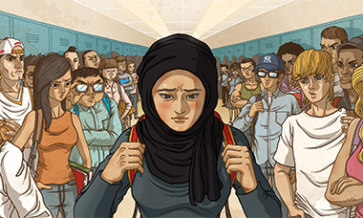
Prejudice is an affective feeling towards a person based on their perceived group membership. The word is often used to refer to a preconceived, usually unfavourable, evaluation of another person based on that person's political affiliation, sex, gender, beliefs, values, social class, age, disability, religion, sexuality, race/ethnicity, language, nationality, beauty, occupation, education, criminality, sport team affiliation or other personal characteristics.

- Read the news extracts below and highlight any evidence of prejudiced attitudes.

- Answer the questions following each extract.

News extract 1

James Parke, 22, was on a night out which ended in him fighting for his life. James, who is a trainee police officer, was having fun with friends when up to 20 boys, some as young as 14, started shouting homophobic abuse at them. James was repeatedly punched and kicked in his face and body by the boys and he was left with several skull and facial fractures.
Who is the prejudice directed towards?
What is the prejudiced attitude?

News extract 2

More than 7,600 viewers complained about racism on the reality show; Celebrity Big Brother. Viewers complained that the contestants of Big Brother were racially abusing the Bollywood star Shilpa Shetty. They claimed that Shetty, from India, was being victimised and bullied. Shetty, 31, broke down in tears after allegedly being taunted about her skin colour, accent and cooking.
What is the prejudiced attitude?
Who is the prejudice directed towards?
News extract 3

Sky Sports presenters Andy Gray and Richard Keys have been accused of sexism after making several comments about a female referee, called Sian Massey. They commented on her understanding of the offside rule during a Premier League match. The commentators believed their microphones were switched off but were actually recorded making remarks such as:
‘Somebody better get down there and explain offside to her.’
‘Can you believe that? A female linesman. Women don’t know the offside rule.’

Who is the prejudice directed towards?
What is the prejudiced attitude?

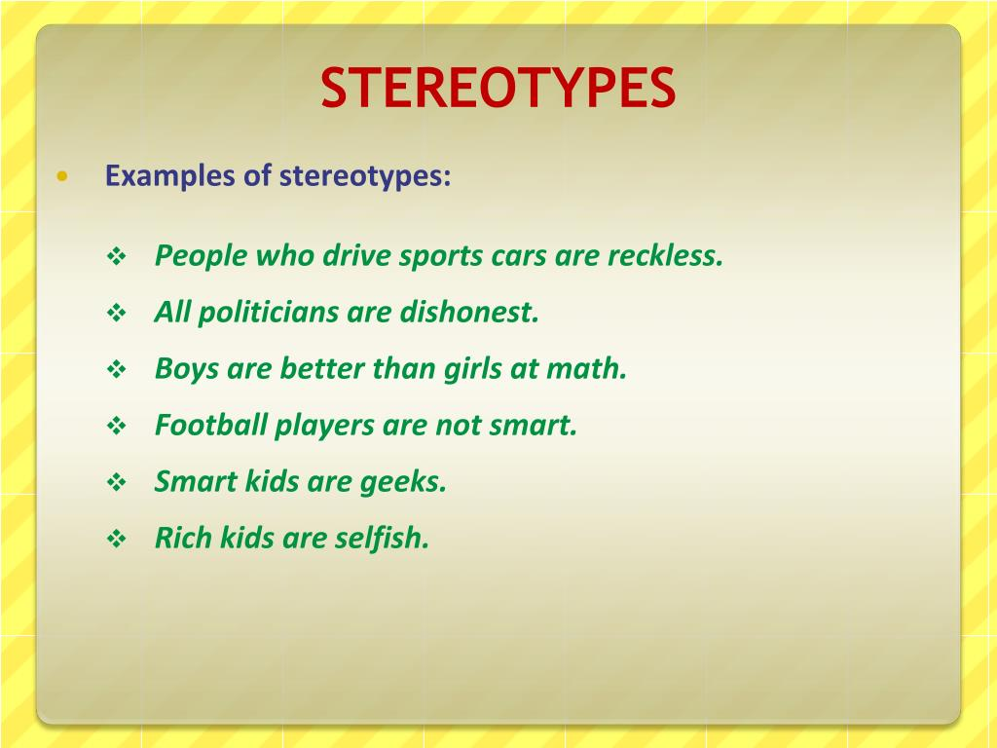

- Remember that stereotypes are wrong ideas. Please write 10 stereotypes that you have heard. Following the examples above.
a.
b.
c.
d.
e.
f.
g.
h.
i.
j.

EXPRESSIONS TO DESCRIBE PEOPLE

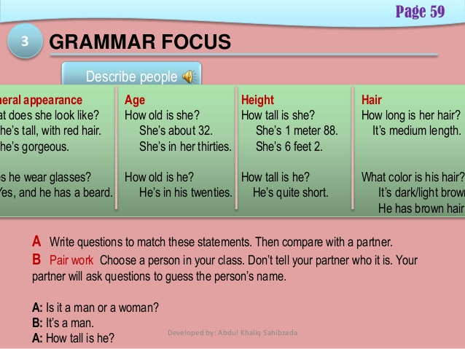
Look at this example:
Elena is tall, she is wearing black jeans, she is about 20 years old, she has dark eyes, she looks like a friendly person.

- Use at least once every expression above (is / has / looks like), to describe three of your classmates.
Classmate 1:

Classmate 2:

Classmate 3:

