UNIT 1: GO GLOBAL!
Name: ____________________Class: 10th Grade (2° Medio) Teacher: Valentina Espinoza
Date: April, 2020.
Objective: Develop cultural awareness and comprehension of your own culture as well as others.

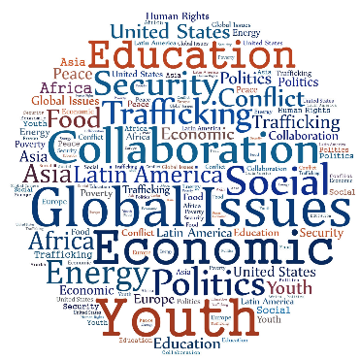
LESSON 1 EXPLORING GLOBAL ISSUES

- Answer in English these questions.

- In your opinión, what is a global issue?
__________________________________________________________________
__________________________________________________________________
- Write at least 3 global issues.

- _______________________________________________________________
- _______________________________________________________________
- _______________________________________________________________

- GLOBAL WARMING MESSAGE BOARD (read, you can use translator)
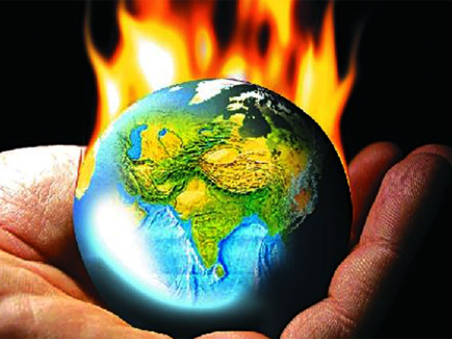
A message board on a weather website asked its readers to write in with their views on global warming and climate change.
Here is a selection of their messages.

Gonzalo – I’m all in favour of global warming. I grow tropical plants so for me the warmer the weather is the better!

Tanya – In 20 years time the traditional British weather will be a thing of the past. We’ll have a climate like the south of France. People will be healthier as they’ll spend more time outdoors. Just think, dining al fresco in the summer months. It’ll be great!

Luis – no one can tell me that global warming isn’t happening. We’ve just had the hottest year on record! My sister lives in the north of Spain and she said that it is beach weather there and it’s November. I mean it’s not normal is it?

Kevin – When I was a boy we used to have heavy snow most years. Since the early 90s all we’ve had is a light dusting of snow. It must be due to global warming.

Ruth – You only have to switch on the news to see the crazy things the weather is doing. There are so many floods, hurricanes and droughts. It’s the extreme weather conditions caused by global warming.

Oliver – There’s no such thing as global warming. It’s all media hype to brainwash people. If they told us the moon was made of cheese often enough people would believe it!
Mark – The world will never be the same again, but that’s how it has always been. It changes constantly and nature and man can adapt to these changes. If we couldn’t, human life on the planet would have finished years ago.

- ANSWER in english

• Who do you agree with most? Why?

__________________________________________________________________
__________________________________________________________________
• Who do you disagree with? Why?
__________________________________________________________________
__________________________________________________________________

• Write to the message board? Put your message here. YOU CAN USE PHRASES TO EXPRESS OPINION:

I THINK THAT – PIENSO QUE
I BELIEVE THAT- CREO QUE
IN MY OPINION – EN MI OPINIÓN
I AGREE – ESTOY DE ACUERDO
I DISAGREE – ESTOY EN DESACUERDO

__________________________________________________________________
__________________________________________________________________
__________________________________________________________________

- Think of things to put in the recycling columns. The words must all begin with the given letter.

 | Paper / wood | Plastic | Metal | Glass | Organic
B (example) | Book | Bin | Bycicle | Bulb | Banana
C
T
G

